**Your guide to heart surgery**

**At the department of Cardiac Surgery, Mediterranean Hospital**

This manual has been compiled to help you prepare for your surgery.

Includes general information on:

• The operation you will undergo

• Your stay in the hospital

• Your recovery

**Contents:**

**Part 1 - Understanding the type of surgery**

**Part 2 - Prepare for your surgery**

**Part 3 - The surgery**

**Part 4 - Recovery**

**Part 1 - Understanding the type of surgery**

• Aortic coronary bypass

• Valve surgery

**Coronary artery bypass grafting**

The coronary arteries surround the heart like a crown (corona - which is why they are called coronary arteries). They carry blood to the heart muscle (myocardium) and can narrow or block over time. If one or more of them is blocked, the blood cannot reach the myocardium.

This can cause:

• Heart attack or heart damage

• It can make the heart weaker

• Pain (angina)

• Shortness of breath, easy fatigue or leg swelling

During coronary artery bypass surgery, another route of blood flow to the myocardium is created, bypassing the obstruction site. This reduces the risk of further heart damage.

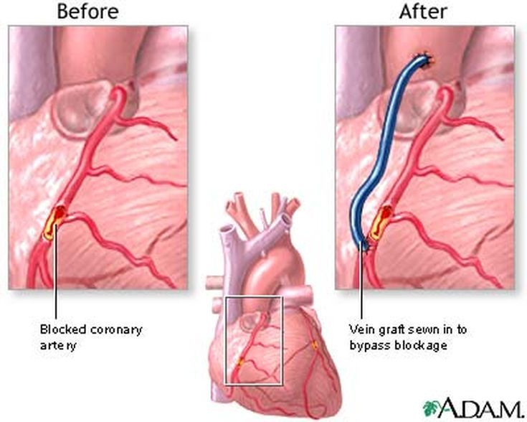

**How does this operation work?**

A healthy vessel is taken from another part of the body. This is called a transplant. This graft is used to bypass the obstruction at your coronary artery. Removing this vessel that will be used as a graft does not affect the flow of blood to the point from which it was removed. If you have more than one obstructions then more than one graft can be used. The surgeon may use one or more of the following vessels as grafts:

• A vein part of your leg (clear vein)

• An artery in your hand (arterial artery)

• Arteries in the chest (internal mammary arteries)

**Valve disease**

Your heart is pumping blood to the rest of your body. Inside your heart, blood flows through one direction. There are 4 such valves in your heart. These are the aortic, pulmonary, mitral and tricuspid valves.

One or more of these valves may not work properly. They may either not open properly (stenosis) or they may not close properly (deficiency). This makes it harder for the heart to pump blood to the rest of your body.

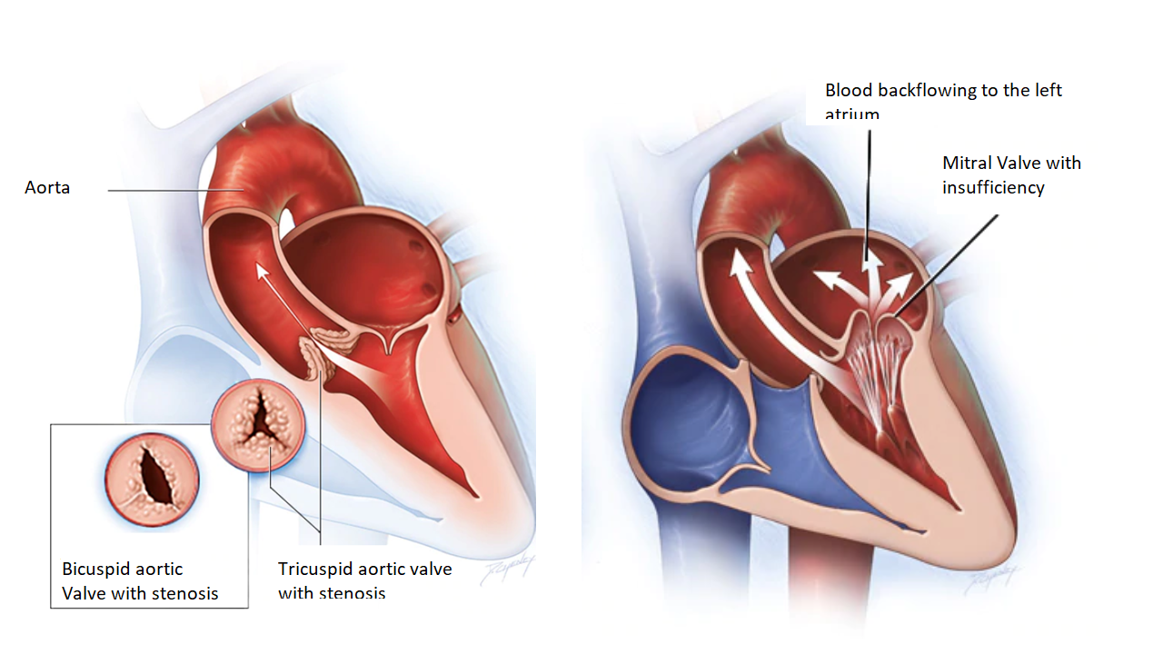

|  |  |
| --- | --- |
| **In case of stenosis**  When the valve does not fully open, the problem is called stenosis.  In these cases, the blood must pass through a narrow opening. So the heart has to work harder to push the blood out of the valve | **n case of insufficiency**  When the valve does not close sufficiently, a quantity of blood returns to the chamber from which it came. So the heart has to circulate this blood twice. |

**What are the symptoms of valvular disease?**

You may have one or more of the following symptoms:

• Difficulty breathing when lying down, exercising, or feeling stressed

• Pain, pressure, numbness or tightness in the chest, neck, back or arms (angina).

• Feeling dizzy or weak

• Easy fatigue, especially during activity or as the day progresses.

• Nocturnal awakening with cough or difficulty breathing

• Fast or irregular pulse

• Feeling of fluttering in the chest

• Leg swelling

These symptoms may get worse over time or appear suddenly.

**How is it treated?**

Different diseases need different treatments. Your doctor will talk to you about which treatment is best for you. In some, the original plan for the operation may change during the procedure.

There are 3 main ways to treat valve disease in the operating room:

• Valve repair

• Replace your valve with a mechanical valve

• Replace your valve with a biological valve

**Part 2 - Prepare for your surgery**

**What should I bring with me for admission?**

• All the medicines you take inside their authentic boxes

• The CD with your coronary angiography

• Your last electrocardiogram

• The last heart ultrasound you have done

• The CD and the result of your CT scan (if you have one)

• Other recent exams

• Slippers with good grip on the bottom

• Bra for women

**Do not bring with you:**

• Perfume

• Items of emotional value, jewelry

• Lots of cash

• Alcoholic beverages

Please do not bring valuables with you.

**What if I am anxious before surgery?**

It's normal to be anxious and nervous about your surgery. We encourage patients to talk with their family or a close friend about their concerns.

Ways to help reduce your anxiety:

If you have any questions about the operation, talk to your doctor.

You can follow relaxation techniques, such as going for a walk or listening to music.

**If I smoke?**

We ask all our patients if they smoke. If you are a smoker we can help you control your desire to smoke while you are in the hospital with nicotine products.

**Make a list of things you have to do**

Before surgery, make your schedule for after you leave the hospital. This will make your return home smoother.

Calculate that you will be discharged on the 5th or 6th day after surgery (if the day of surgery is day 0).

**Schedule:**

• Have someone take you home on the day you are discharged - estimate it will be around 09:30 in the morning.

• Someone who will help you with the housework, shopping and preparing your food.

• Make an appointment with your cardiologist to see you after surgery.

**The day before surgery**

**Washing**

The night before surgery and the morning of surgery, you will be washed with an antiseptic soap. Thoroughly wash your entire body (add a little to your shampoo).

**Food and beverage**

The night before surgery:

Do not eat or drink anything after midnight (not even water)

Do not chew gum

**Part 3 - The surgery**

**How long does the operation take?**

The duration of the operation usually depends on the number of grafts. It usually lasts 3 to 6 hours.

**Part 4 - Recovery**

After the operation you will be transferred to the intensive care unit.

The beds in the unit are located in an open space and do not have dividers between them. This helps staff monitor patients closely and react quickly.

We understand that this is a time of great stress for you and your family. The next part answers questions you may have while you are in an intensive care unit

Visits are not allowed when there is something urgent in the unit, when special tests are performed or when patients are admitted. In these cases, staff will ask you to wait outside.

**Contact via phone**

A person will be the link between the unit and the family. A family member can call the ICU directly at 25200191 for an update (at 12:00 and/or 20:00).

**Inside the Unit**

The unit is a busy place. Get ready to see a lot of cables, tubes and other equipment.

**Your family member**

He or she may be asleep or sedated. Surgery can change the color of the skin and make it redder, paler, or even gray. Patients may appear swollen, mainly on the hands, face and feet. They may be colder to the touch. This is common after heart surgery.

**Monitors**

Monitors have alarms alerting staff that something needs their attention. It's not always a cause for concern. Sometimes even a small movement of the patient can make a monitor beep**.**

**Oxygen**

Patients in the unit very often need extra oxygen. This can be supplied with a mask, nasal cannula or a respirator.

**Respirator**

The respirator is a machine that helps the patient breathe. Patients on a respirator cannot speak.

**Lines and tubes**

The tubes help to drain fluids that usually collect from the operation. Some of the lines are used to give medicines and antibiotics and others to measure various parameters. Don't worry if you see an air bubble in the line. The lines are closely monitored.

**Discharge from the ICU**

When you are ready, you will be taken to the cardiac surgery ward. You will not leave the unit unless you are fully ready. Staying in the unit longer doesn't necessarily mean there's a problem.

**Transfer to the ward**

You will spend a few days in the ward before going home. Usually 4-5 days. Some patients need to stay longer.

**Manage your pain**

You may feel pain or discomfort around the wounds. You may even feel pain in your back and arms. This is normal.

Painkillers will help you recover faster. It will be easier for you to walk, breathe and cough if you are not in pain.

Ask for your painkiller if you are in pain.

Your nurse will ask you if you are in pain and how much. You can use this scale:

0 1 2 3 4 5 6 7 8 9 10

No pain The worst pain

**Take care of your wounds**

After your operation you will have an incision in the center of your chest. If you have undergone a coronary artery bypass grafting, you may also have an incision on your leg. Nurses will monitor your wounds daily.

|  |  |
| --- | --- |
| **Please Don’t**  **No sign** | * • Do not touch the wounds with your hands * • Do not apply ointments, powders or antibiotic creams to the incisions * • Do not lift more than 5 kg during the first 6 weeks after surgery * • Do not use your hands to push or pull your body * • Do not soak in the bath until your wounds are completely healed |
| **You CanThumbs up sign** | * • If you have itching you can apply a cool patch on top * • You can take a shower 3 to 5 days after the day of surgery * • In the shower, gently clean the incisions with soap and water. Dry by touching and not rubbing with a clean towel * • You can clean the incision at home with common, non-scented soap |
| **Before you go home** | If you have stitches or metal clips we will tell you if you need and when to remove them |

**Mobilization after surgery**

The following is the usual post-surgery mobilization program. This may be a little different for some patients.

**On the 1st day**

The staff will help you sit on the edge of the bed

**On the 2nd day**

The staff will help you sit in the chair for all your meals. The staff will also help you take 2 short walks.

**On the 3rd day**

The staff will help you sit in the chair for all your meals. You can take a shower and put on your own clothes.

You can do 3 walks

**On the 4th and 5th day**

You can do 4 to 5 walks.

If you have stairs at home we will make sure that you can go up and down the stairs before you leave the hospital.

**Delirium**

It's another word for confusion. Delirium usually occurs in elderly patients in the hospital. They may appear drowsy or slow in their reactions (hypoactive delirium) or be aggressive and anxious (overactive delirium). Sometimes a patient can have both forms.

Patients with delirium may not know where they are, have problems with attention span or memory. They may also have hallucinations and sleep disorders.

**How is delirium treated?**

Nursing and medical staff will try to find the cause of delirium through some tests and they will try to control the patient. When the cause is found, it will be treated.

**Constipation**

It is very common after surgery. This is a result of the painkillers and the minimal activity you have.

It is treated with oral laxatives or suppositories.

In addition, increasing your activity and a high-fiber diet can help.

**Discharge day**

Please have someone pick you up on the day of the discharge from the hospital. You will know this day in advance. The person who will take you home should come to the ward at 09:30 to listen to the instructions that will be given to you for home care.

**What do I need to know and what should I do before I leave the hospital?**

Before you leave you will receive instructions for:

Your medication

Which activities you are allowed to do and which not

Your diet

Your appointments with:

* Your cardiologist
* Your surgeon (3 weeks post discharge)

**Before leaving the hospital, make sure that:**

• You have the identification card for your valve (in case you underwent valve replacement)

• You have received instructions for your anticoagulant (blood thinner if you are on one)

• Have some one to take you home

• Have someone to prepare meals for you and help you with your groceries