Mediterranean Hospital of Cyprus

**What you need to know if you have had heart surgery**

Useful information for patients and their families

**Table of Contents**

Introduction

Exercises for cough and deep breathing

How to lie down and get out of bed

Planning for walking

Warning Signs and Symptoms / Tips for Pain

Daily exercises

Activities

Tips for daily activities

Tips for energy and strength

Contact your doctor

**Introduction**

Heart surgery puts your body under a lot of stress. It is normal to feel tired with simple activities such as dressing, showering, sitting, or visiting friends.

When you return home after surgery and for the next 6-8 weeks, you should:

• Rest often and do not let yourself feel tired

• Plan at least two breaks a day to rest

• Rest after each meal

• Rest before and after each exercise

**Exercises for cough and deep breathing**

Take 10 deep breaths and then cough 2 times. Repeat this exercise for 2 weeks after you have gone home.

When coughing, hold a towel or blanket to push against your incision.

**How to lie down and get out of bed**

When lying down or getting out of bed, you need to protect your chest.

**To get out of bed follow these steps:**

* Cross your arms in front of your chest
* Bend your leg towards the outside of the bed
* Roll your body out by taking your feet out of bed
* With the help of your elbow, push your body and sit on the edge of the bed
* Stand up after a few minutes

**Plan for walking**

When you get home, you should start walking at least 30-45 minutes a day for 4-6 weeks. Walking will strengthen your heart, lungs and muscles.

In the beginning start with frequent and short walks and slowly increase the duration so as to give the right time to your heart to adapt.

**Walking instructions** (See instructions in the table below)

Day by day try to increase the time you spend walking. You should walk slowly and always on a level road without uphill or stairs. Take walks in your house, in the hallway of your apartment building, in the gym.

In about a month you will be able to walk at least 30 minutes a day. When you get to this point, you can increase the time you walk, provided you do not feel short of breath or tired at all. If you feel tired or short of breath, pause to rest and start walking again.

Avoid walking outdoors in summer when the temperature is above 28 degrees Celsius or when there is high humidity. In addition, avoid temperatures below 10 degrees, as well as cold winds.

|  |  |  |  |
| --- | --- | --- | --- |
| Day | Number of walks | Minutes | Notes |
| 1 | 6 | 5 |  |
| 2 | 5 | 6 |  |
| 3 | 4 | 7 |  |
| 4 | 4 | 8 |  |
| 5 | 3 | 9 |  |
| 6 | 3 | 10 |  |
| 7 | 3 | 11 |  |
| 8 | 3 | 12 |  |
| 9 | 2 | 13 |  |
| 10 | 2 | 14 |  |
| 11 | 2 | 15 |  |
| 12 | 2 | 16 |  |
| 13 | 2 | 17 |  |
| 14 | 2 | 18 |  |
| 15 | 2 | 19 |  |
| 16 | 2 | 20 |  |
| 17 | 2 | 21 |  |
| 18 | 2 | 22 |  |
| 19 | 1 | 23 |  |
| 20 | 1 | 24 |  |
| 21 | 1 | 25 |  |
| 22 | 1 | 26 |  |

**Warning signs and symptoms**

Do not do any exercise if you have the following symptoms:

• Chest pain (angina)

• Shortness of breath

• Dizziness or mild headache

• Feeling of pulsation - fluttering in the chest

• Fatigue

• Sweating

• Nausea or tendency to vomit Swelling in the legs

• Sternal instability

Tell your doctor (cardiologist) immediately if you experience any of the above symptoms. Stop walking until your doctor tells you what to do. If symptoms persist for more than 10 minutes, call an ambulance or go to the emergency department.

**Tips for pain management**

It is normal to feel mild pain after surgery, even when you return home. The doctor will give you painkillers and over time the pain will stop.

Contact your doctor if the pain gets worse, occurs more often or the painkillers do not work.

**Daily exercise**

After heart surgery, you are very likely to feel the following:

• less flexible body

• you get tired more easily

• Exercise becomes more difficult than before

**Instructions for exercises:**

All the above is normal. The following easy exercises will strengthen you and make you more flexible. Try doing them once a day for 4 weeks, at a slow pace and taking continuous, deep breaths. With these exercises you should not normally feel pain or discomfort.

1. Circular shoulder movement: Move your shoulders in a circular motion forward and then backwards. Repeat 5 times for each direction.

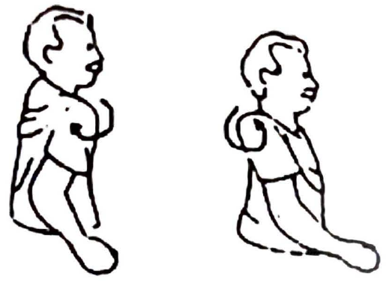

1. Raise your hands: Take a deep breath as you raise your arms until they reach above your head. Repeat 3 times.

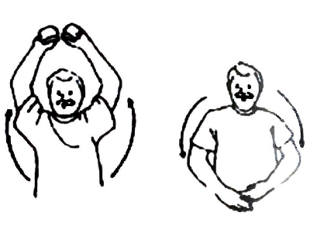

1. Turn your head: Slowly turn your head to the right and stay that way for 10-20 seconds. Bring your head forward and repeat, turning to the left. Repeat 3 times in each direction.

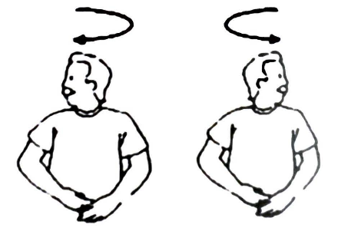

1. Body rotation: Fold your arms in front of your chest. Turn your body (from the waist up) to the right and stay that way for 10-20 seconds. Bring your body back to the center and turn your body to the left. Repeat 3 times in each direction.

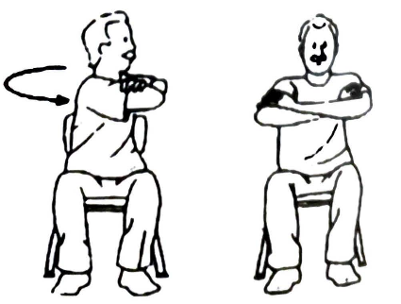

1. Stretching to the side: Sit with your back upright in a hard chair. Tilt your body to one side of the chair and let your hand slide to the side of the chair. Slowly return your body to its original position. Do the same on the opposite side. Repeat 3 times on each side.

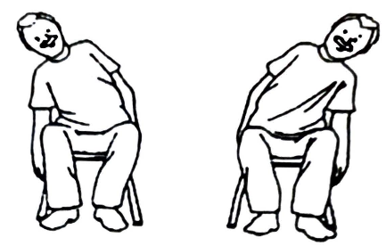

1. Stretch your legs: Sit with your back upright in a hard chair. Stretch your leg forward and hold for 10-20 seconds. Lower your leg slowly and repeat 3 times for each leg.

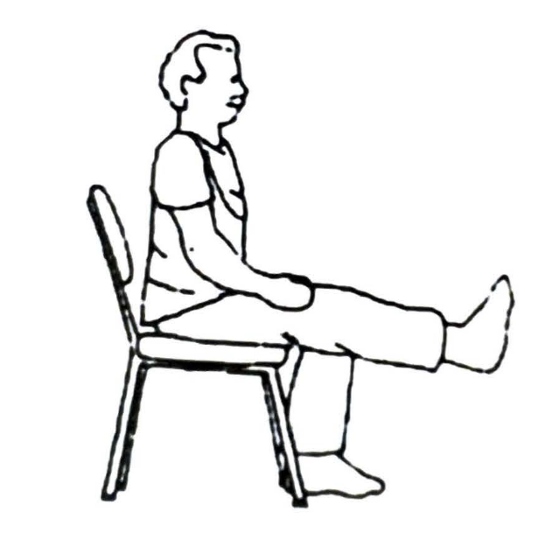

1. Ankle Exercises: Lift one foot slightly above the ground and move the tip of the foot up and down. Repeat 10 times on each leg.

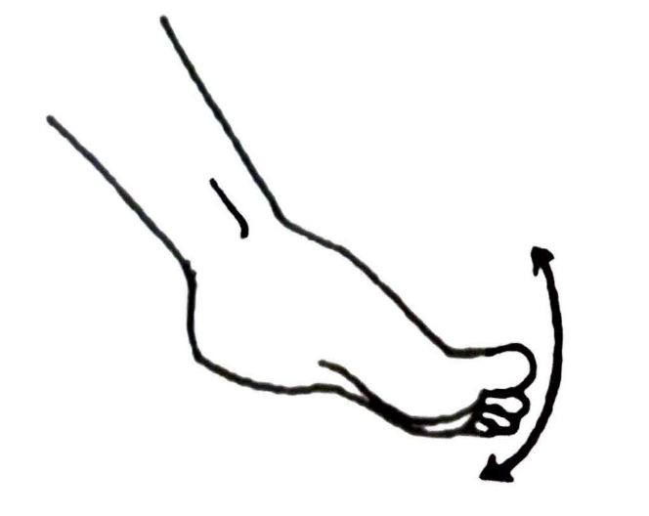

**Activities**

After heart surgery, your sternum needs 4-6 weeks to return to its original state. Some activities should be avoided until this time has elapsed.

Activities to avoid:

• lift, pull or push a weight over 5 kg (basket of clothes, pets, armchairs, grills, bulky items)

• carry children or babies on your shoulder

• driving

• sit in the front seat of the car (airbags)

• heavy household chores (sweeping, mopping or scrubbing)

• open glued lids from jars

• walking in very cold or hot weather

Activities you should do:

• move slowly

• use lukewarm water when bathing

• daily exercise

**Tips for daily activities**

**Things you can do when you feel ready:**

• light household chores

• preparation of snacks

• light manual work

• stair climbing

• sex

• table laying

• visit friends

• static bike (without resistors)

**Things you can do 6-8 weeks after surgery**

• vacuum cleaner and scrubber

• mopping and wiping

• window cleaning

• simple gardening

• digging

• painting

• lifting objects over 5 kg

• dance •

cycling

• swimming

• running

• driving a car

**Activities you can do 3 months after your operation (after consulting your surgeon)**

• heavy household chores (barbeque, etc.)

• gardening with heavy tools (shovel, etc.)

• diving

• rowing

• ski

• riding a motorcycle

• Bowling

• cutting wood

• using a lawn mower

• tree pruning

**Daily activities**

**Getting dressed**

• Dress in loose clothing

• Do not stretch both arms back together

• Do not bend forward

• When putting on pants, bring your foot close to your body

• The bra in women reduces traction on the incision (use gauze to avoid friction with the wound) Bathing

• Do not rub your incision

• Gently touch the towel to the incision to dry

• Do not use strong-smelling soaps

• Do not let water run directly on your incision

• Do not raise both hands back together

• Do not use very hot or very cold water

• Do not take a shower if you feel dizzy

• Avoid soaking in the bathtub

**Toilet**

• Do not make too much effort to defecate

• Do not push the toilet with your hands to get up

• Do not turn sharply to pull the cistern

Tell your doctor if you have constipation

**Tips for energy and strength**

After heart surgery, it is normal to feel more tired than before. Try to balance the time you rest with the time you spend on your activities. This way, you will have more energy to do the things you want.

**Rest**

• Take frequent breaks to rest

• Do your activities intermittently

• Take your time and do not rush to finish something

• Learn to notice the signs that your body is giving (fatigue, trembling, sweating, shortness of breath)

**Set priorities**

• Make a list of things you need to do

• Leave the less important activities for later

• Ask your family or friends to help you

**Posture**

• Keeping your posture correct saves you more power and energy

• When sitting, try to change your posture often

• When you sit you are more relaxed than standing

**Contact your doctor**

Call 25-200048 to make an appointment with your surgeon 20 days after discharge.

*The information in this book is based on international guidelines, heart surgery guidelines, and training programs.*